These Perilous Times
Vol. 18, No. 10, May 21, 2026

“Anything Before God is Idolatry”

“Nebuchadnezzar the king made an image of gold, whose height was threescore cubits, and the breadth thereof six cubits: he set it up in the plain of Dura, in the province of Babylon. Then Nebuchadnezzar the king sent to gather together the princes, the governors, and the captains, the judges, the treasurers, the counsellors, the sheriffs, and all the rulers of the provinces, to come to the dedication of the image which Nebuchadnezzar the king had set up. Then the princes, the governors, and captains, the judges, the treasurers, the counsellors, the sheriffs, and all the rulers of the provinces, were gathered together unto the dedication of the image that Nebuchadnezzar the king had set up; and they stood before the image that Nebuchadnezzar had set up. Then an herald cried aloud, To you it is commanded, O people, nations, and languages, That at what time ye hear the sound of the cornet, flute, harp, sackbut, psaltery, dulcimer, and all kinds of music, ye fall down and worship the golden image that Nebuchadnezzar the king hath set up: And whoso falleth not down and worshippeth shall the same hour be cast into the midst of a burning fiery
furnace. ” Dan. 3:1-6 KJV (Emphasis supplied)

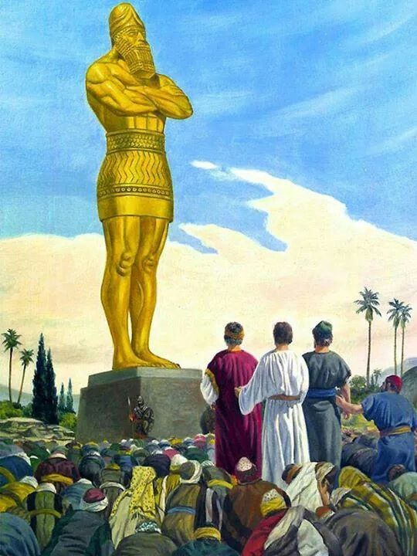
What does this mean for us?

Obvious Signs Do Tell The Season

“Thou shalt have no other gods before me.
Thou shalt not make unto thee any graven image, or any likeness of anything that is in heaven above, or that is in the earth beneath, or that is in the water under the earth.
Thou shalt not bow down thyself to them, nor serve them: for I the Lord thy God am a jealous God, visiting the iniquity of the fathers upon the children unto the third and fourth generation of them that hate me.” Exodus. 20:3-5 (Italics supplied)

Now while Paul waited for them at Athens, his spirit was provoked within him when he saw that the city was given over to idols.” Acts 17:16 NKJV

Last week a very tall golden statue of a politician was erected on a 7 foot pedestal to depict the politician’s greatness, strength and resilience. Many religious leaders, commentators & critics swiftly compared the statue to King Nebuchadnezzar and the “biblical golden calf” and accused supporters of elevating politics into idol worship. Among attendees at the unveiling were clergy blessing the statue. The “largeness of it all” to declare one’s greatness in grandiose ways seems to share the similar intent Nebuchadnezzar had when erecting the 90 foot statue on the plain of Dura. Brothers and Sisters, we must be careful to heed the commandment of God to not worship or make idols of anyone or anything.

“He who loves father or mother more than Me is not worthy of Me. And he who loves son or daughter more than Me is not worthy of Me. And he who does not take his cross and follow after Me is not worthy of Me.” Matt. 10:37, 38 NKJV

